WANTED!
WANTED FOR HORSE THEFT AND RUSTLING
REWARD: Restored faith in humanity for neighborhood children
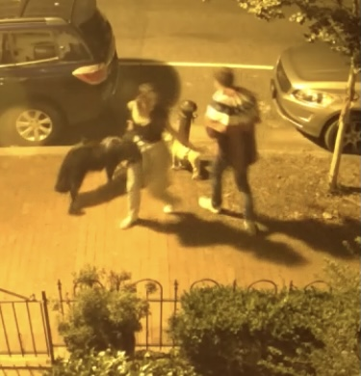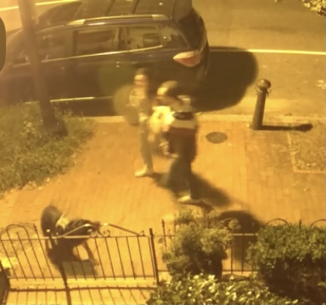
400 blk of 6th St SE - 2:16 am September 4TH
Please return Blondie the horse to her hitching post
Broke her chain to steel her – also stole American Flag bunting

