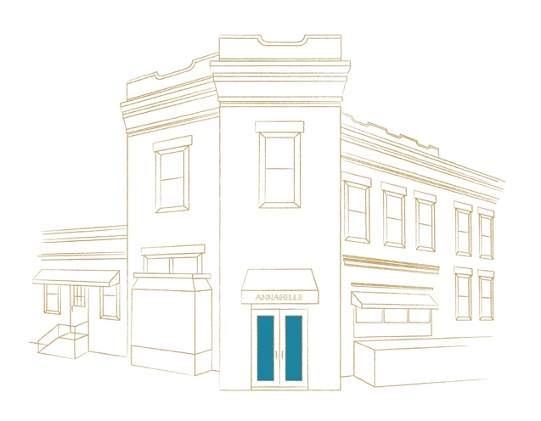

BAR MENU

BAR MENU

Barlow-Burger 14
House Aged Angus and Kraut, Gruyere,
Thousand Island

Pot Pie 12
Confit Chicken Thigh, Root Vegetables

Golden Buck 11
Cheddar~Lager Fondue, Chard, Poached Egg

Chicken Liver Mousse 12
Pickled Onions, Huckleberry Jam, Crostini

Good and Bad 12
Crudités and Steak Fries, Onion Rings
Zesty Tartare Sauce and Labneh

Smoked Trout Rillette 13
Grilled Baguette, Trout Roe, Mustard Seeds
Contains Nuts, (v) Vegetarian Option
Consuming Raw or Undercooked Meats, Poultry, Seafood, Shellfish or Eggs May Increase Your Risk of Foodborne Illness, Especially if You Have Certain Medical Conditions

Contains Nuts, (v) Vegetarian Option
Consuming Raw or Undercooked Meats, Poultry, Seafood, Shellfish or Eggs May Increase Your Risk of Foodborne Illness, Especially if You Have Certain Medical Conditions

Imported and Domestic Cheese
Perfectly Matured in our Cellar
Served with our Almond ~ Fig Bread, Honeycomb and Annabelle Jam
$8 each
3 for $22
5 for $38

Barlow-Burger 14
House Aged Angus and Kraut, Gruyere,
Thousand Island

Pot Pie 12
Confit Chicken Thigh, Root Vegetables

Golden Buck 11
Cheddar~Lager Fondue, Chard, Poached Egg

Chicken Liver Mousse 12
Pickled Onions, Huckleberry Jam, Crostini

Good and Bad 12
Crudités and Steak Fries, Onion Rings
Zesty Tartare Sauce and Labneh

Smoked Trout Rillette 13
Grilled Baguette, Trout Roe, Mustard Seeds
Contains Nuts, (v) Vegetarian Option
Consuming Raw or Undercooked Meats, Poultry, Seafood, Shellfish or Eggs May Increase Your Risk of Foodborne Illness, Especially if You Have Certain Medical Conditions

Imported and Domestic Cheese
Perfectly Matured in our Cellar
Served with our Almond ~ Fig Bread, Honeycomb and Annabelle Jam
$8 each
3 for $22
5 for $38

