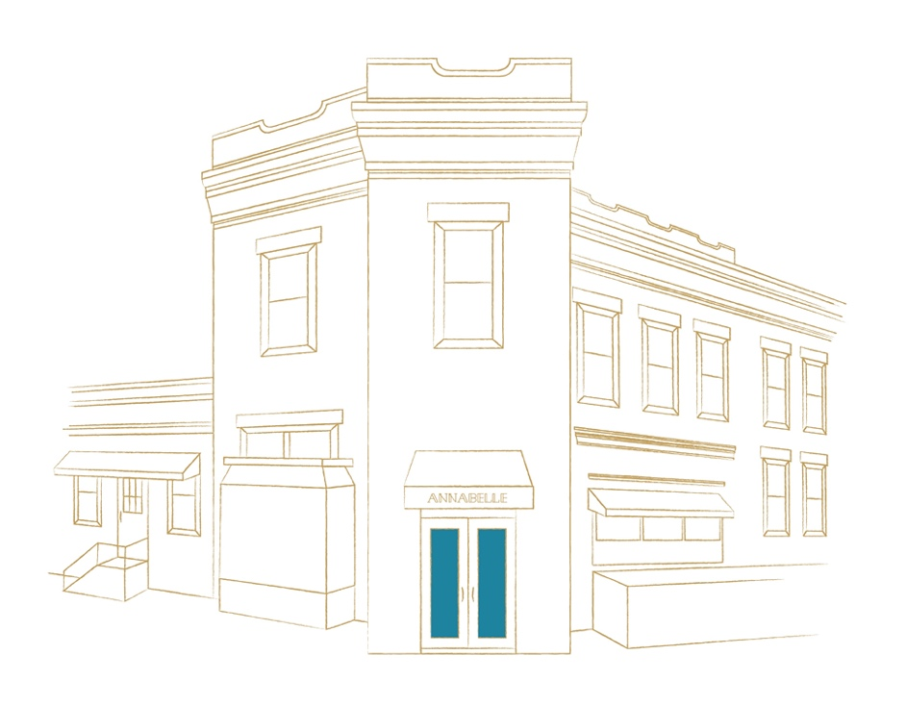

WINES BY THE GLASS
SPARKLING

NV Sommariva Prosecco Brut, Conegliano Valdobbiadene 12
NV J. Lassalle Brut 1er Cru ‘Cuvée Préférence’, Chigny-les-Roses 18
NV Laurent Perrier Brut Cuvée Rosé, Tours-sur-Marne 27

WHITE

2018 Dönnhoff Riesling ‘Estate’, Nahe 14
2018 WillaKenzie Pinot Blanc, Willamette Valley 12
2018 Pascal Jolivet Sancerre, Loire 15
2017 Louis Michel Chablis 1er Cru Butteaux, Bourgogne 21
2017 Routestock Chardonnay, Carneros 14
2017 DuMOL Chardonnay ‘Estate Vineyard’, Sonoma 19

ROSÉ

2018 Lioco ‘Indica’ Rosé (Carignan), Mendocino 13

RED

2015 Georges Mugneret-Gibourg Bourgogne Pinot Noir, Vosne Romanée 19
2017 Square Peg Pinot Noir, Russian River Valley 17
2017 Descendientes de José Palacios ‘Petalos’ Bierzo Mencia, Castilla y León 13
2017 Tenuta Sette Ciele ‘Yantra’ Cabernet/Merlot Blend, Tuscany 15
2013 Bodegas Hermanos Peciña Rioja Riserva Tempranillo, Rioja 16
2013 Neal Cabernet Sauvignon, Napa Valley 20

COCKTAILS BY BAR BARLOW 14

CLASSIC

SCOFFLAW
Buffalo Trace Bourbon, Dry Vermouth, Grenadine, Citrus

NAKED & FAMOUS
Ilegal Mezcal, Yellow Chartreuse, Aperol, Lemon

JUNGLE BIRD
Blended Rum, Pineapple, Campari, Lime

SAZERAC
Sazerac 6yr. Rye, Absinthe, Peychaud’s

PENICILLIN
Dewar’s Scotch, Ginger Honey, Lemon, Laphroig 10yr.

NEO CLASSIC

PAPER PLANE
Buffalo Trace Bourbon, Amaro Nonino, Aperol, Lemon

NEGRONI
Hayman’s Gin, Carpano Antica, Campari

BEE’S KNEES
Hayman’s Gin, Honey, Lemon

DARK ‘N’ STORMY
Gosling’s Black Seal Rum, Lime,
Ginger Beer

COBBLER
Alvear Sherry, Demerara Syrup, Citrus, Seasonal Fruit

BEERS 8

Schlafly Pilsner, MO
Maine Beer Co. Pale Ale, ME
Bell’s ‘Two Hearted’ IPA, MI
Great Lakes Porter, OH
Chimay Blue, Belgium

CHAMPAGNE & SPARKLING

2016 Schramsberg Brut Rosé, North Coast 82

NV Sommariva Prosecco Brut, Conegliano Valdobbiadene 60

NV Lanson Brut ‘Black Label’, Reims 98
2015 Bérêche & Fils Brut 1er Cru ‘Rilly-La-Montagne’, Ludes 232
NV J. Lassalle Brut 1er Cru ‘Cuvée Préférence’, Chigny-les-Roses 96
NV André Clouet Brut Rosé, Bouzy 108
NV Paul Bara Brut Rosé ‘Grand Cru’, Bouzy 132
NV Coutier Brut Blanc de Blancs ‘Grand Cru’, Ambonnay en magnum 242
NV Laurent Perrier Brut Cuvée Rosé, Tours-sur-Marne 112
NV Pol Roger Brut Réserve, Epernay 118
NV Billecart-Salmon Brut Rosé, Mareuil-sur-Aÿ half 86/168
2008 Pol Roger Brut, Epernay 168
NV Jacques Selosse ‘Substance’ Brut Blanc de Blancs, Avize 728
NV Krug Brut ‘Grand Cuvée’, Le-Mesnil-sur-Oger half 188
NV Delamotte Brut Blanc de Blancs, Le-Mesnil-sur-Oger half 78/152

WHITE WINE
THE NEO CLASSICS

2018 WillaKenzie Pinot Blanc, Willamette Valley 52
2017 Peter Michael Sauvignon Blanc ‘Les Apres Midi, Knights Valley Sonoma 148
2017 Arbe Garbe White Blend, Russian River Valley 58
2018 Pahlmeyer ‘Jayson’ Sauvignon Blanc, Napa Valley 88
2018 Spottswoode Sauvignon Blanc, Napa Valley half 48/92
2017 Matthiasson White Blend, Napa Valley 66
2018 Tablas Creek ‘Esprit Blanc’, Paso Robles 96

2016 DuMOL Chardonnay ‘Estate’, Russian River Valley 88
2017 Ramey Chardonnay, Russian River Valley half 48/92
2017 Peay Chardonnay, Sonoma Coast 146
2015 Scribe Chardonnay, Sonoma Coast 82
2016 Kongsgaard Chardonnay, Napa Valley 258
2017 Matthiasson Chardonnay ‘Linda Vista Vineyard’, Napa Valley 76
2017 Routestock Chardonnay, Carneros 58
2016 Ceritas Chardonnay ‘Trout Gulch, Santa Cruz Mountains 138
2017 Liquid Farm Chardonnay ‘White Hill’, Sta. Rita Hills 98
2017 Tyler Chardonnay ‘Zotovich Vineyard’, Sta. Rita Hills 122

THE CLASSICS

2017 Louis Michel Chablis 1er Cru ‘Montee de Tonnerre’ 105
2017 Louis Michel Chablis 1er Cru ‘Butteaux’ 92
2015 Christian Moreau Chablis Grand Cru ‘Les Clos’ 212
2016 Domaine Costal Chablis 1er Cru ‘Vaillons’ 86
2017 Jean-Phillipe Fichet Bourgogne Blanc ‘Vieilles Vignes’ 102
2015 Sylvain Patiaille Bourgogne Aligoté 78
2017 Paul Pernot Puligny-Montrachet ‘Clos des Folatieres’ 192
2016 Jean-Noël Gagnard Chassagne-Montrachet 1er Cru ‘Blanchots Dessus’ 362
2016 François Jobard Meurault 1er Cru ‘Poruzots’ 328
2015 Domaine Roulot Meursault 1er Cru ‘Clos des Bouchères’ 808
2017 Jean-Phillipe Fichet Meursault ‘Gruyaches’ 232
2016 Château de Beauregard Pouilly-Fuissé half 58/106

THE CLASSICS CON’T

2017 Domaine Lupin Frangy Roussette de Savoie, Savoie 56
2013 Domaine Faury Condriu, Rhône 122
2014 Domaine Marc Sorrel Hermitage Blanc, Rhône 388
2017 Alain Graillot Crozes-Hermitage Blanc, Rhône 88
2018 Domaine Fournier Sancerre ‘Les Belles Vignes’, Loire half 40/76
2017 Delaporte Sancerre ‘Silex’, Loire 86
2018 Pascal Jolivet Sancerre, Loire 58
2017 Domaine Huet Vouvray Sec ‘Clos de Bourg’, Loire 92

2015 Marcus Molitor Riesling Spätlese ‘Wehlener Klosterberg’, Mosel 92
2018 Dönnhoff Riesling ‘Estate’, Nahe 62
2015 Weingut Stadt Krems Riesling ‘Grillenparz’, Kamptal 88
2013 Malat Grüner Veltliner ‘Gottschelle’, Kremstal 102
2016 Veyder-Malberg Grüner Veltliner ‘Wösendorfer Hochrain’, Wachau 168

2018 J. Hoffstätter Pinot Grigio, Alto Adige 56
2018 Arnaldo Caprai Grechetto ‘Grecante’, Umbria 54
2015 Villa Bucci Verdiccio dei Castelli di Jesi Classico Riserva, Le Marche 152
2018 Raúl Pérez Albariño ‘A Cruz das Ánimas’, Rias Baixas 72

ROSÉ WINE
2018 Lioco ‘Indica’ Rosé (Carignan), Mendocino 60
2017 Chêne Bleu Vaucluse Rosé (GSM Blend), Rhône 84
2017 Pascal Jolivet Sancerre Rosé (Pinot Noir), Loire 68

RED WINE
THE NEO CLASSICS

2016 Nicholas-Jay Pinot Noir, Willamette Valley 156
2017 Cristom Pinot Noir ‘Mt. Jefferson Cuvée’, Willamette Valley half 44/82
2016 Lingua Franca Pinot Noir ‘The Plow’, Eola Amity Hills 136
2017 Littorai Pinot Noir ‘Les Larmes’, Anderson Valley 152
2015 Waits-Mast Pinot Noir ‘Nash Mill Vineyard’, Anderson Valley 92
2018 Littorai Pinot Noir, Sonoma Coast 122
2018 Square Peg Pinot Noir, Sonoma Valley 74
2014 Freeman Pinot Noir, Russian River Valley 112
2015 Porter Creek ‘Estate’ Pinot Noir, Russian River Valley 98
2012 Rhys Pinot Noir ‘Horseshoe Ranch’, Santa Cruz Mountains 278
2016 Calera Pinot Noir, Central Coast 68
2016 Presqu’ile Pinot Noir, Santa Maria Valley 78

2017 A. Rafanelli Zinfandel, Dry Creek Valley half 46/92
2016 Red Car Syrah ‘Estate Vineyard’, Fort Ross-Seaview 128
2017 Anthill Farms Syrah ‘Campbell Ranch Vineyard’, Sonoma Coast 86
2017 Square Peg Zinfandel, Sonoma 56
2017 Turley Zinfandel ‘Frederiks Vineyard’, Sonoma Valley 112
2018 Lieu Dit Cabernet Franc, Santa Ynez Valley 72

2015 Gramercy Cellars Cabernet Sauvignon ‘Lower East’, Columbia Valley 76
2013 Pahlmeyer Proprietary Red, Napa Valley 412
2015 Snowden Cabernet Sauvignon ‘The Ranch’, Napa Valley 142
2014 Neal Family Vineyards Cabernet Sauvignon, Napa Valley 89
2015 Corison Cabernet Sauvignon, Napa Valley half 98/192
2013 Rafael et Fils Estate Cabernet Sauvignon ‘Oak Knoll’, Napa Valley 98
2015 J. Davies ‘Diamond Mountain District’, Napa Valley 212
2016 Truchard Cabernet Sauvignon, Carneros 68

THE CLASSICS

2014 Joseph Roty Marsannay ‘Ouzeloy’ 108
2015 Joseph Roty Marsannay half 66
2016 Olivier Bernstein Gevrey-Chambertin Village 242
2017 Mongeard-Mugneret Vosne-Romanée half 78/144
2015 Georges Mugneret-Gibourg Bourgogne Rouge, Vosne Romanée 86
2006 Bertrand Machard de Gramont Nuits-Saint-Georges ‘Les Vallerots’ 132
2013 J.F. Mugnier Nuits-Saint-Georges ‘Clos de la Maréchale’ 196
2014 Follin-Arbelet Aloxe-Corton 1er Cru ‘Les Vercots’ 182
2017 Louis Boillot Volnay 1er Cru ‘Les Brouillards’ 202
2017 Jean Foillard Beaulolais Village, Beaujolais 62
2017 Domaine de la Grand’Cour Fleurie ‘Les Déduits’, Beaujolais 94
2018 Château Thiven Côte de Brouilly, Beaujolais 76

2016 Jamet Côte Rôtie, Rhône 408
2013 Bernard Bergaud Côte Rôtie, Rhône half 88/156
2015 Jean-Claude Marsanne Saint-Joseph, Rhône 82
2016 Alain Graillot Crozes-Hermitage Rouge, Rhône 78
2013 Domaine Lionnet Cornas ‘Terre Brulée’, Rhône 132
2011 Chêne Bleu Vaucluse ‘Héloïse’, Rhône 228
2016 Domaine Raspail-Ay Gigondas, Rhône 86
2006 Château de Beaucastel Châteauneuf-du-Pape, Rhône 298
2017 Château de Beaucastel Châteauneuf-du-Pape, Rhône half 98/182
2016 Domaine du Vieux Télégraphe Châteauneuf-du-Pape, Rhône 228

2009 Domaine de Trevallon, Provence 252
2013 Château Simone Palette, Provence 148
2013 Domaine Comte Abbatucci ‘Faustine’, Corsica 76
2015 Joguet Chinon ‘Cuvée Terroir’, Loire Valley 66
2014 Domaine Larruau Margaux, Bordeaux 90
2015 Château D’Armailhac 5ème Cru Classé, Bordeaux 192

2013 Le Piane ‘Boca’, Piemonte 148
2014 Ca’ Viola Dolcetto D’Alba ‘Barturot’, Piemonte 62
2013 Fantino Barolo ‘Vigne Vecchie’, Piemonte 136
2014 Marchesi di Barolo Barolo, Piemonte 182
2010 Giuseppe Mascarello Barbera d’Alba ‘Scudetto’, Piemonte 108
2013 Paolo Scavino Barolo ‘Monvigliero’, Piemonte 118
2016 Russiz Superiore Cabernet Franc, Friuli 68
2016 Castelli di Volpaia Chianti Classico Riserva, Tuscany 86
2010 Biondi-Santi Brunello di Montalcino ‘Annata’ Tuscany 562
2014 Tenuta Carpazo Brunello di Montalcino, Tuscany half 76/138
2016 Tenuta Sette Cieli ‘Yantra’, Tuscany 66
2011 Arnaldo Caprai Montefalco Sagrantino ‘Collepiano’, Umbria 128
2016 Valle dell’Acate ‘Il Frappato’, Sicilia 54
2016 Alberto Graci Etna Rosso ‘Arcurìa’, Sicilia 122

2015 Terroir al Limit Priorat ‘Torroja Vi de Vila’, Catalonia 129
2013 Bodegas Hermanos Peciña Rioja Reserva, Rioja 78
2012 CVNE Rioja Imperial Gran Reserva, Rioja 188
2016 Antidoto Ribera del Duero, Castilla y León 70
2017 Descendientes de José Palacios ‘Petalos’ Bierzo Mencia, Castilla y León 62

SWEET WINES
2015 Château Roûmieu-Lacoste Sauternes, Bordeaux (375mL) Glass 14 Bottle 58
2001 Château De Malle Sauternes, Bordeaux (750mL) Bottle 160

2016 Domaine de Durban Muscat de Beaumes-de-Venise, Rhône (375mL) Glass 10 Bottle 48
NV Patrick Bottex Bugey Cerdon ‘La Cueille’, Savoy (750mL) Bottle 66

2013 Royal Tokaji Wine Company 5 Puttonyos Aszú, Hungary (500mL) Glass 16 Bottle 128

2019 La Spinetta Moscato d’Asti ‘Bricco Quaglia’, Piemonte (375mL) Bottle 44

2001 Gunderloch Riesling Auslese ‘Nackenheimer Rothenberg’, Rheinhesen (750mL) Bottle 180

PORTS & MADEIRA
PORT

Fonseca ’10 Year’ Tawny (750mL) Glass 10 Bottle 90
Churchill’s ’20 Year’ Tawny’ (500mL) Glass 18 Bottle 180
Grahams ’40 Year’ Tawny (750mL) Glass 42 Bottle 400

MADEIRA

Rare Wine Co. ‘Boston Bual’ Special Reserve (750mL) Glass 14 Bottle 138
Broadbent ‘10 Year’ Malmsey (750mL) Glass 12 Bottle 116
1982 D’Oliveira Bual (750mL) Bottle 342

All Dessert Wines, Port and Madeira are 2 ounce pours

