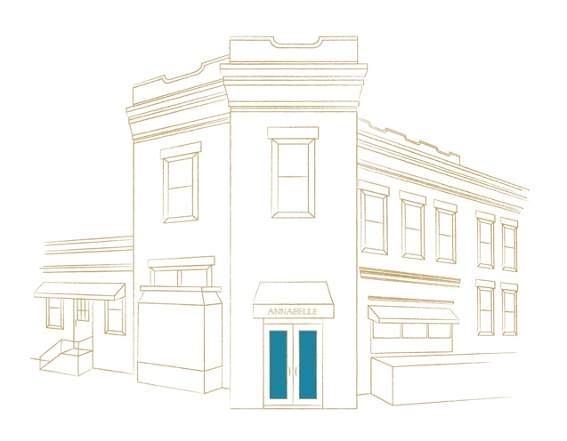

RESOLUTION

RESOLUTION

RESOLUTION 12
Charred but not Forgotten
Goat Cheese Cake, Caramelized Buckwheat Puff Pastry,
Huckleberry-Balsamic Sorbet, Spicy Urfa Honey

Pine Nut Tart
Cornmeal Crust, Rosemary Semifreddo
Lemon Cream, Port Reduction

Baba au Rhum
Pepita Brittle, Smoked Vanilla Ice Cream,
Crispy Red Kuri, Lime Bubbles

Sacher Torte
Chocolate Stout Cake, Chocolate
Hazelnut Mousse, Kumquat Preserves,
Cajeta Ice Cream

Pavlova
Roasted Pineapple Compote,
Ginger Crémeux, Passionfruit Sorbet

Annabelle Ice Cream & Sorbet
Flavors of The Day

Imported and Domestic Cheese
Perfectly Matured in our Cellar
Served with our almond ~ fig bread, honeycomb and Annabelle jam
$8 each
3 for $22
5 for $38

Contains Nuts, (v) Vegetarian Option

RESOLUTION 12
Charred but not Forgotten
Goat Cheese Cake, Caramelized Buckwheat Puff Pastry,
Huckleberry-Balsamic Sorbet, Spicy Urfa Honey

Pine Nut Tart
Cornmeal Crust, Rosemary Semifreddo
Lemon Cream, Port Reduction

Baba au Rhum
Pepita Brittle, Smoked Vanilla Ice Cream,
Crispy Red Kuri, Lime Bubbles

Sacher Torte
Chocolate Stout Cake, Chocolate
Hazelnut Mousse, Kumquat Preserves,
Cajeta Ice Cream

Pavlova
Roasted Pineapple Compote,
Ginger Crémeux, Passionfruit Sorbet

Annabelle Ice Cream & Sorbet
Flavors of The Day

Imported and Domestic Cheese
Perfectly Matured in our Cellar
Served with our almond ~ fig bread, honeycomb and Annabelle jam
$8 each
3 for $22
5 for $38

Contains Nuts, (v) Vegetarian Option

