475 School Street Halfway House Fact Sheet

RFP Basics
Solicitation number: | RFP-200-1270-ES
Issued on: | January 15, 2016
Issued by: | Federal Bureau of Prisons (“FBP”)
Solicitations due: | Initially on March 11, 2016, extended to April 26, 2016 at 1:00 p.m. PDT.
Synopsis of Solicitation: | The FBP seeks contractors to provide Residential Reentry Center (“RRC”) and Home Confinement services within the counties of Prince Georges and/or Montgomery, Maryland; Arlington and/or Fairfax, Virginia; and/or the District of Columbia (DC)
Services to be provided by contractor | - RRC services will consist of 300 beds for male offenders.  - Home Confinement services will consist for a total of 150 placements for male offenders.  - The government may award any combination of up to four (4) contracts not to exceed 300 RRC beds and 150 Home Confinement Placements
Offeror’s notice requirements | - Must notify and seek input from local law enforcement and two levels of locally elected government officials.  - Submit proof of notification to the respective Congressional delegate (Eleanor Holmes Norton) for the proposed location and intent to respond to the RFP for services located in the District.  - Submit documentation to evidence community support or acknowledgment for the location of the proposed site.
GEO Reentry, Inc. Proposal for 475 School Street Proposal
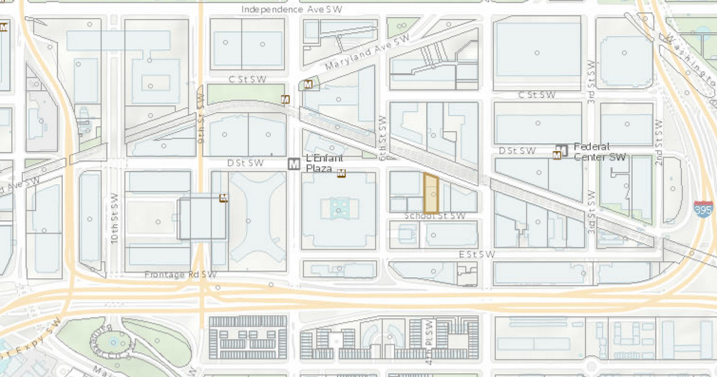Councilmember Charles Allen received a letter from Geo Reentry, Inc., dated March 8, 2016, notifying him that GEO Reentry, Inc. has submitted a response to this RFP.
Key Details -
- Property Location: 475 School St. SW (currently owned by Willschool Holdings LLC, an entity based in Rye, New York)
- Term of proposed contract: five (5) years, including options
- Capacity: 300+ beds
- Residents: Male
- Estimated Performance Period: To commence November 1, 2016
GEO Reentry, Inc.
- Second largest for profit prison operator in the U.S.
Zoning
- Zoned: C-3-C
- Allowed by Right*: 741.5 The following uses shall also be permitted as a matter of right in a C-3 District: … (c) Community-based residential facility … miscellaneous
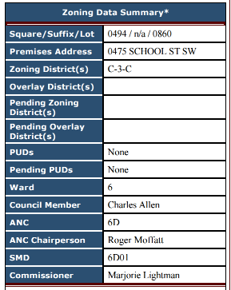
- Community-based residential facility - a residential facility for persons who have a common need for treatment, rehabilitation, assistance, or supervision in their daily living… and facilities formerly known as convalescent or nursing home, residential halfway house or social service center, philanthropic or eleemosynary institution, and personal care home.
*There may be a possibility of contesting that an RRC does not fall into the “Adult Rehabilitation Home” sub-category of Community-based residential facility, but that might be a tough case to make.
Licensing/Certificate of Occupancy
- Basic business license
Notice Requirement for Halfway House Facilities Located Near Schools
- The Mayor must “give at least 60 days written notice to the District of Columbia Board of Education or the governing body of a private or parochial school of the proposed establishment of …a halfway house, to be located within 400 feet of a school, or adjacent school grounds in the District of Columbia, used for the instruction of minors.”
- The Mayor must “give great weight to written comments of the District of Columbia Board of Education in regard to the establishment or current operation of… a halfway house, or drug treatment center located within 400 feet of a District of Columbia public school, of the adjacent school grounds, used for the instruction of minors.”
The property in question is within 400 feet of Washington Global Public Charter School (located at 525 School Street).
Actions Taken to Date
- Initial conversations with SWNA, ANC, MPD
Next Steps
- If possible, determine to whom GEO Entry addressed the required notice to local law enforcement and the required notice to the second “level” of locally elected government officials (assuming that the first “level” of locally elected government officials was Councilmember Allen).
- Confirm support for opposing the location of an RRC at 475 School Street SW with Councilmember Allen, Mayor Bowser, local police precinct, Chief Lanier, Park Police, Delegate Norton, and if known, others to whom notice was sent by GEO.
- Among parties listed above, agree who will write to GEO Reentry (copy to the Contracting Officer).
- Consider some combination of Mayor Bowser, Chief Lanier and Park Police personnel to meet with someone as high up in the Bureau of Prisons as possible.

